**AAUW Community Hub How to Self-Renew for Existing Members**

The Community Hub allows existing members to log in and renew their membership and donate.

Login to your **Personal Snapshot** one of two ways.

* From the AAUW homepage click **Log In** in the upper right corner



* or go to [my.aauw.org](https://my.aauw.org/NC__Login?startURL=%2F)

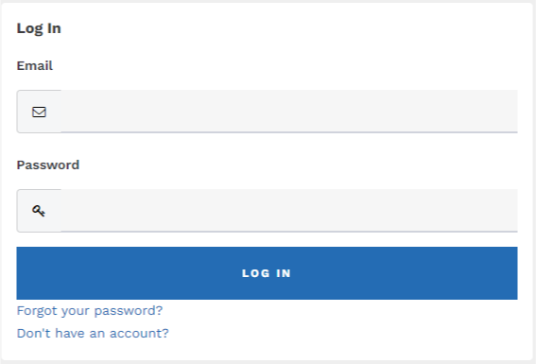

Click the **Forgot your password?** if you are an existing member but logging in to the Community Hub Personal Snapshot for the first time. If you’ve logged in before, enter email/password then click **LOG IN.**

On the **Personal Snapshot** page, scroll down and click **Renew.** This takes you to the **Membership Management** page to review/update your contact information, then click **Next**.

* Review rate information then **Select** **Membership Type**, then click **Next**

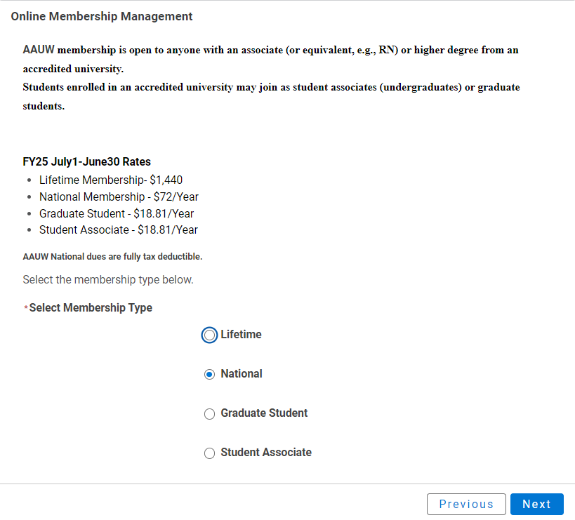

**NOTE**:  After selecting ***Graduate Student*** or ***Student Associate*** (undergraduate) enter the future expected graduation date, then click **Next** (up to 2 times).

* Click **Yes** if you wishto add Branch or State memberships then click **Next**
* Select the **Branch**, scroll to bottom of the list, click **Next**

(**NOTE**: If multiple branches have been selected, you must choose one to be the primary.)

* Select the **State**, scroll to end of the list, click **Next**
* Click **Yes** or **No** to include a donation, then click **Next**
  + If **Yes**, enter amount in **Donation Amount** field, then click **Next**
  + If **No**, click **Next**

On **Checkout** page

* Review National, State and Branch dues
* Select Payment Type
  + **Pay Now – Save Payment**

**NOTE**: If you wish to save a payment method for the branch, click *Add, edit, or remove your saved payments* in the **My Payment Methods** section. Click **Add Bank Account** or **Add Credit Card**, complete all fields, agree to **Terms and Conditions** (if applicable), then click **Save**. Return to **Checkout** to process your payment.

* + **Pay Now – New Credit Card**
    - Enter payment information, then click **Submit**
    - Save confirmation for your records