**AAUW Community Hub How to Self-Join for New Member Prospects**

Community Hub allows prospects to create an account to make donations and/or join AAUW.

**From the Community Hub Login page:**  
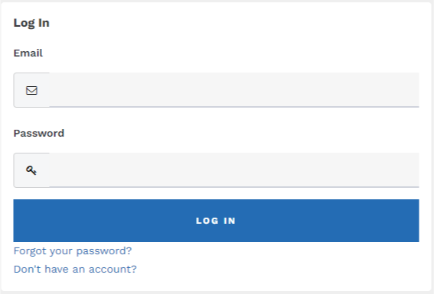

1. Click the **Don’t have an account?** link if you’re not yet a member or donor.

2. Enter the required information, then click **Create Account** to access your **Personal Snapshot**.

On the **Personal Snapshot** page, scroll down and click **Join Now.** This takes you to the **Membership Management** page to enter your contact information. Then click **Next**.

* Review rate information, select **Membership Type,** then click **Next**

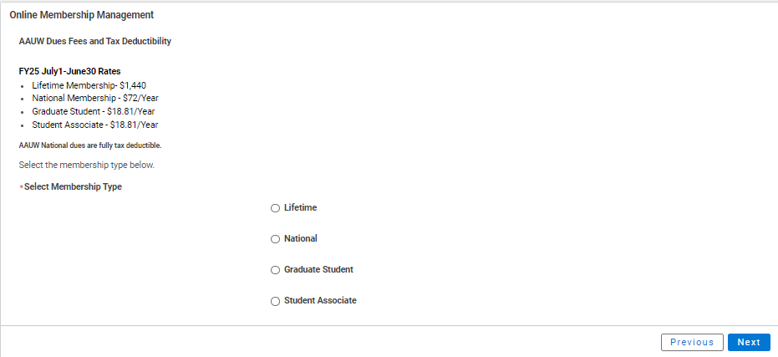

**NOTE**: After selecting ***Graduate Student*** or ***Student Associate*** (undergraduate), enter the future expected graduation date, then click **Next** (up to 2 times).

* Click **Yes** if you wishto add Branch or State memberships then click **Next**
* Select the **Branch**, scroll to bottom of the list, click **Next**

(**NOTE**: If multiple branches have been selected, you must choose one to be the primary.)

* Select the **State**, scroll to end of the list, click **Next**
* Click **Yes** or **No** to include a donation, then click **Next**
  + If **Yes**, enter amount in **Donation Amount** field, then click **Next**
  + If **No**, click **Next**

On **Checkout** page

* Review your membership selections and total.
* Enter **Coupon Code** (if provided in advance of joining by your local branch, i.e. *Shape the Future Campaign*)
* Select Payment Type
  + **Pay Now – Save Payment**

**NOTE**: If you wish to save a payment method for the branch, click *Add, edit, or remove your saved payments* in the **My Payment Methods** section. Click **Add Bank Account** or **Add Credit Card**, complete all fields, agree to **Terms and Conditions** (if applicable), then click **Save**. Return to **Checkout** to process your payment.

* **Pay Now – New Credit Card**
  + Enter payment information, then click **Submit**
  + Save confirmation for your records